**Contribution of each product towards yearly sales**

**File name: What is the contribution of each product towards total sales yearly**

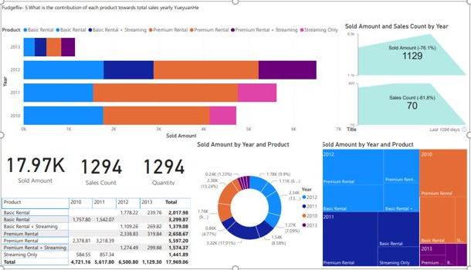

**Best performing suppliers early**

**Fudge Mart**

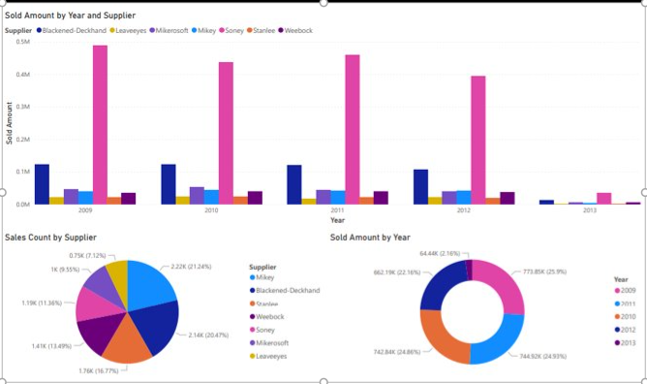

**Fudgeflix**

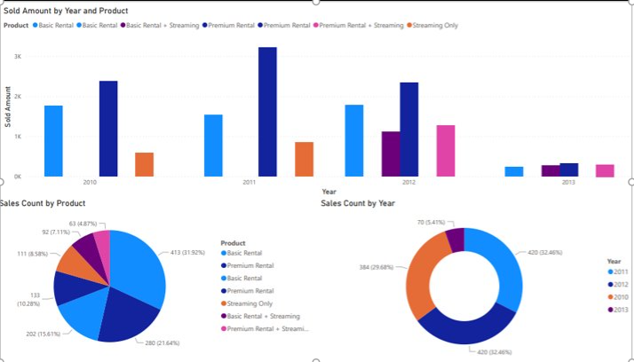

**Company Performance in terms of sales**

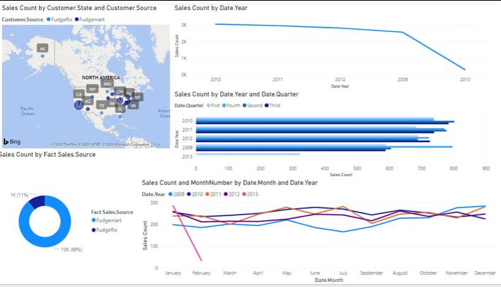

**Sales performance for fudgeflix**

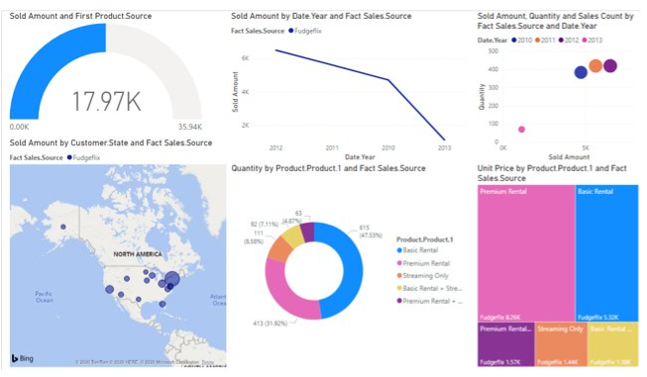

**Sales performance for fudgemart**

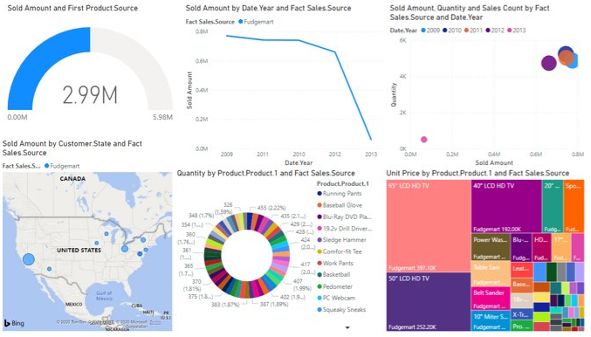

**Products in high demand for fudgeflix**

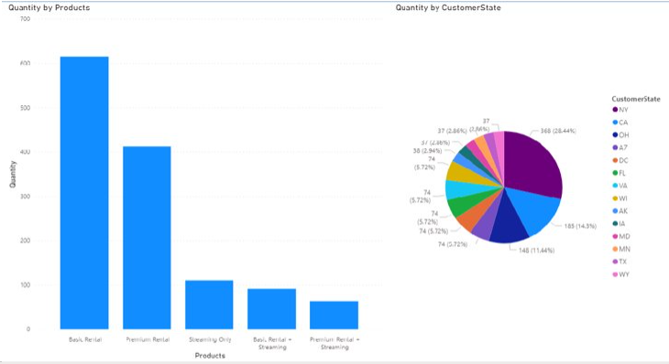

**Products in high demand for fudgemart**

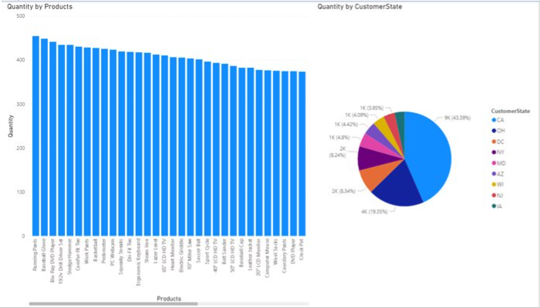

**Top Performing states fudgemart**

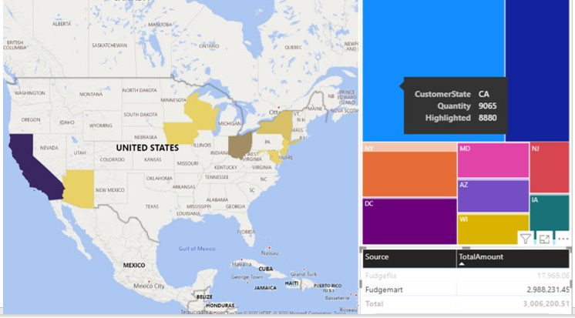

**Top performing states fudgeflix**

